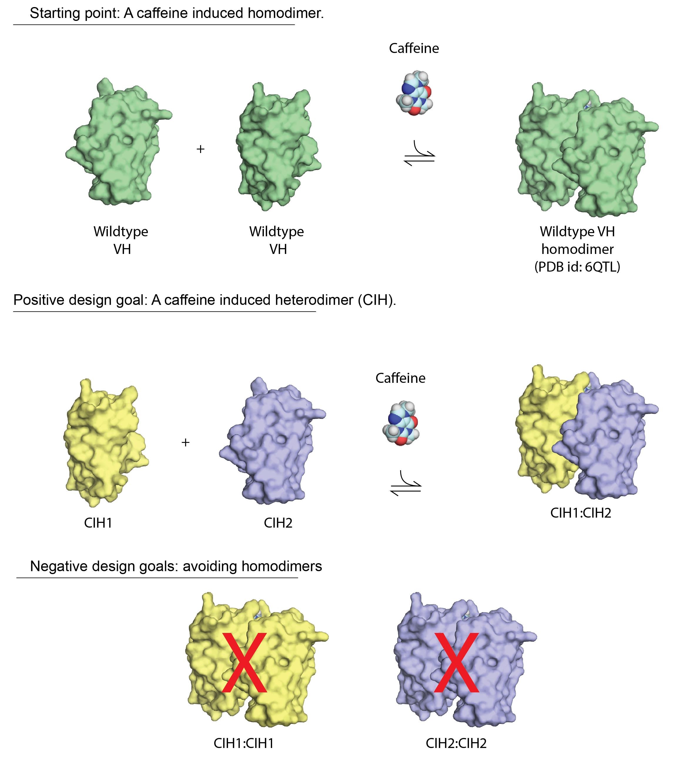

Wildtype VH sequence:

SQVQLVESGGGLVQAGGSLRLSCTASGRTGTIYSMAWFRQAPGKEREFLATVGWSSGITYYMDSVKGRFTISRDKGKNTVYLQMDSLKPEDTAVYYCTATRAYSVGYDYWGQGTQVTVSS

Sequence complex 1 - Mutation group A

Mutations: K45R/K45E

CIH1_01:

SQVQLVESGGGLVQAGGSLRLSCTASGRTGTIYSMAWFRQAPG**R**EREFLATVGWSSGITYYMDSVKGRFTISRDKGKNTVYLQMDSLKPEDTAVYYCTATRAYSVGYDYWGQGTQVTVSS

CIH2_01:

SQVQLVESGGGLVQAGGSLRLSCTASGRTGTIYSMAWFRQAPG**E**EREFLATVGWSSGITYYMDSVKGRFTISRDKGKNTVYLQMDSLKPEDTAVYYCTATRAYSVGYDYWGQGTQVTVSS

Sequence complex 2 - Mutation group A+

CIH1_02:

SQVQLVESGGGLVQAGGSLRLSCTASGRTGTIYSMAWFRQAPG**R**EREFLATVGWSSGITYYMDSVKGRFTISRDKGKNTVYLQMDSLKPEDTAVYYCTATRAYSVGYDYWGQGTQVTVSS

CIH2_02:

SQVQLVESGGGLVQAGGSLRLSCTASGRTGTIYSMAWFRQAPG**E**EREFLATVGWSSGITYYMDSVKGRFTISRDKGKNTVYLQMDSLKP**R**DTAVYYCTATRAYSVGYDYWGQGTQVTVSS

Sequence complex 3 - Mutation group B

CIH1_03:

SQVQLVESGGGLVQAGGSLRLSCTASGRTGTIYSMAWFRQAPGKE**D**EFLATVGWSSGITYYMDSVKGRFTISRDKGKNTVYLQMDSLKPEDTAVYYCTATRAYSVGYDYWGQGTQVTVSS

CIH2_03:

SQVQLVESGGGLVQAGGSLRLSCTASGRTGTIYSMAWFRQAPGKEREFLATVGWSSGITYYM**R**SVKGRFTISRDKGKNTVYLQMDSLKPEDTAVYYCTATRAYSVGYDYWGQGTQVTVSS

Sequence complex 4 - Mutation group B+

CIH1_04:

SQVQLVESGGGLVQAGGSLRLSCTASGRTGTIYSMAWFR**D**APGKE**D**EFLATVGWSSGITYYMDSVKGRFTISRDKGKNTVYLQMDSLKPEDTAVYYCTATRAYSVGYDYWGQGTQVTVSS

CIH2_04:

SQVQLVESGGGLVQAGGSLRLSCTASGRTGTIYSMAWFRQAPGKEREFLATVGWSSGITYYM**R**SVKGRFTISRDKGKNTVYLQMDSLKPEDTAVYYCTATRAYSVGYDYWGQGTQVTVSS

Sequence complex 5 - Mutation groups A&B

CIH1_05:

SQVQLVESGGGLVQAGGSLRLSCTASGRTGTIYSMAWFRQAPG**R**E**D**EFLATVGWSSGITYYMDSVKGRFTISRDKGKNTVYLQMDSLKPEDTAVYYCTATRAYSVGYDYWGQGTQVTVSS

CIH2_05:

SQVQLVESGGGLVQAGGSLRLSCTASGRTGTIYSMAWFRQAPG**E**EREFLATVGWSSGITYYM**R**SVKGRFTISRDKGKNTVYLQMDSLKPEDTAVYYCTATRAYSVGYDYWGQGTQVTVSS

**Sequence complex 6** - Mutation groups A&B (flipped to put negative charges on CIH1).

CIH1_06:

SQVQLVESGGGLVQAGGSLRLSCTASGRTGTIYSMAWFRQAPG**E**E**D**EFLATVGWSSGITYYMDSVKGRFTISRDKGKNTVYLQMDSLKPEDTAVYYCTATRAYSVGYDYWGQGTQVTVSS

CIH2_06:

SQVQLVESGGGLVQAGGSLRLSCTASGRTGTIYSMAWFRQAPG**R**EREFLATVGWSSGITYYM**R**SVKGRFTISRDKGKNTVYLQMDSLKPEDTAVYYCTATRAYSVGYDYWGQGTQVTVSS

Sequence complex 7 - Mutation group C

Note: This mutation was rationally performed (but not computational)

CIH1_07:

SQVQLVESGGGLVQAGGSLRLSCTASGRTGTIYSMAWFRQAPGK**R**REFLATVGWSSGITYYMDSVKGRFTISRDKGKNTVYLQMDSLKPEDTAVYYCTATRAYSVGYDYWGQGTQVTVSS

CIH2_07:

SQVQLVESGGGLVQAGGSLRLSCTASGRTGTIYSMAWF**E**QAPGKER**Q**FLATVGWSSGITYYMDSVKGRFTISRDKGKNTVYLQMDSLKPEDTAVYYCTATRAYSVGYDYWGQGTQVTVSS